3:AM

between saying and doing
Interview by Richard Marshall.
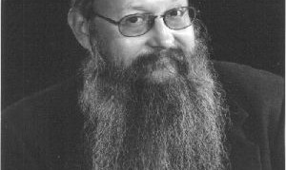
Robert Brandom is the pittsburghegelianasaurus big beast pragmatist lurking in the philosophical jungle. He’s always thinking about the importance of language when thinking about humans, about discursive understanding, about American and Wittgensteinian pragmatism, about analytic pragmatism, about Sellars, about compositionality, about semantic holism, about the Kant-Sellars thesis, inferentialism, AI, German Idealism, Hegel as pragmatist, intentionality, Wittgenstein,expressivism, about why understanding is part of the core of the philosophic enterprise and why he thinks its an exciting time to be working in philosophy. This one’s leaving deep tracks…
3:AM: What made you become a philosopher?
Robert Brandom: My first area of concentration as an undergraduate at Yale was math. (I fell away, but did finish the joint major.) A charismatic young philosophy professor, Bruce Kuklick (who was writing his book on Josiah Royce), introduced me both to the American pragmatists and to the sort of insights intellectual history could shed on their thought. A model-theory course with Jon Barwise, and Richmond Thomason’s introduction to possible worlds semantics focused my interest on the possibilities for our getting a mathematical grip on the phenomena of meaning and conceptual content and (so) understanding. At the same time, reading the pragmatists made me suspicious that the representational paradigm of meaning and content that dominated formal semantics was playing a Procrustean role.
I thought then—as in a significant sense I still do—that where it is possible, a broadly algebraic form of understanding is the very best kind. That is not the kind of understanding we have of each other, including when we understand each other’s sayings and writings. But it did not seem beyond imagining that what we are doing in exercising such non-algebraic discursive or hermeneutic understanding could itself be understood algebraically. The topic was suggested by the pragmatists, and the method was that of the analysts. I took it that in the early ‘70s we had a new and qualitatively superior set of formal tools for undertaking that mathematical semantic enterprise. (It was, of course, a similar naïve enthusiasm for an earlier mathematical toolkit that had motivated Russell, and those for whom he came to speak, at the beginning of the century.) This was for me an inspiring challenge.
3:AM: You link classic analytic philosophy (of Russell and Frege and early Wittgenstein) and American (and late Wittgensteinian) Pragmatism (Peirce, Sellars, Rorty). So for those of us outside all this, can you first say what you take to be salient about analytic philosophy and the linguistic turn?
RB: I am interested in language because it is what makes us sapient, and not merely sentient creatures. I am interested in us as beings who exhibit a distinctive kind of understanding: discursive, that is to say, conceptually articulated understanding. From the beginning I took it to be essential to figure out how to synthesize two perspectives philosophers had developed on this phenomenon. On the one hand, there is the perspective of the logistical tradition of Frege, Russell, Carnap, and Tarski, taking its point of departure from the fact that the first sort of meanings or concepts on which we got a formal grip were the meanings and concepts expressed in abstract, disembodied, monological mathematical calculi. On the other hand, there is the more or less anthropological perspective of the broadly pragmatist tradition that comprises not only Peirce, James, and Dewey, but also the later Wittgenstein and the Heidegger of Being and Time. It is concerned with discursive practices of using natural languages as a feature of the natural history of creatures like us—with what makes it possible for us to engage in such practices, and how we are transformed and empowered by doing so.
These two perspectives line up more narrowly with what I think of as the projects of formal and philosophical semantics. Formal semantics starts with a primitive association of some kind of semantically relevant whatsis with simple expressions, and is principally concerned with algebraically generating on that basis an association of semantically relevant whatsises with complex expressions. Philosophical semantics is after an account of what is we do in our social discursive practices to effect or establish the association of expressions with semantically relevant whatsises, and how such an association can then illuminate the norms that govern the use of those expressions.
These two currents of thought—the logistical tradition of compositional formal semantics that studies language as a mathematical object, and the naturalistic anthropological tradition that studies language as a social practice—correspond to the perspectives within analytic philosophy and pragmatism that I am concerned to synthesize, to bring together into a single synoptic vision.
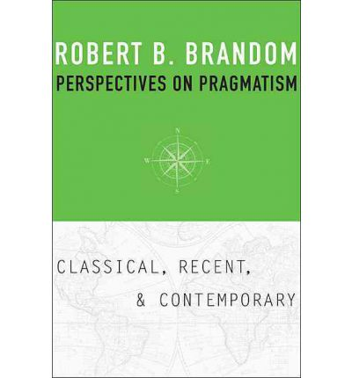
3:AM: And then there’s the pragmatism – both the American and the Wittgensteinian species that you draw upon and develop. Aren’t these an alternative rather than an extension to the analytic approach? Wasn’t the later Wittgenstein of the ‘Philosophical Investigations’ reacting against the analytics – and his earlier self? How do you manage to run pragmatism in the analytic spirit, and why?
RB: It is easy to see pragmatism as not only critical of but antithetical to analytic philosophy’s concern with meanings. Wittgensteinian pragmatism about discursivity urges us to shift our attention from the analyst’s focus on meaning to concern with use—from semantics in the traditional sense to pragmatics in a broad sense. Rorty, like Dewey, wants to replace analytic philosophy’s master-concept of representation by concern with coping and practical agreement. Heidegger relocates the description and explanation characteristic of Vorhandenheit as a late-coming parochial sub-region of the more primordial Zuhandenheit. And so on. Wittgenstein himself seems to have drawn semantically nihilistic conclusions from his foregrounding of the social practices that constitute the use of linguistic expressions. Methodological pragmatists assert that the point of associating meanings with expressions (as theoretical postulates) would be to codify proprieties governing their use. Wittgenstein takes it that the uses in question are so varied and motley, and above all so plastic and variable, as to defy such regimentation. This is a point that his admirer Charles Travis in our own day has underscored with examples exhibiting the unavoidable “occasion sensitivity” of even the most ordinary empirical descriptive vocabulary—from which he has also drawn skeptical conclusions about the prospects for compositional truth-conditional semantics as classically conceived.
But I think concern with meanings and concern with the use of expressions, semantics and pragmatics, ought to be seen as complementing, rather than competing with one another. Methodological pragmatism and semantic pragmatism about philosophical semantics—that is, the claim that all there is to associate meanings (semantically relevant whatsises) with expressions is their use—do not together entail the semantic nihilist conclusions Wittgenstein and Travis want to draw. One of the ways in which classical analytic philosophy read its brief too narrowly is that it did not systematically consider the ways in which the meanings expressed by some vocabularies can make explicit what is implicit in the use of other vocabularies. This is true for instance of vocabularies whose principal expressive role is to serve as pragmatic metalanguages for other vocabularies. Expressions for normative statuses, such as “commitment” and “entitlement” let us say what it is one is doing in endorsing a claim or an inference. Before one had logical vocabulary, one could, I take it, in practice take or treat an inferential transition as appropriate or inappropriate, or two claims as incompatible.
Introducing conditional and negation locutions lets one make those normative attitudes explicit as the contents of claims that are themselves assertible—which is to say in a form in which reasons can be asked and given for them. I agree with Sellars (who follows Kant in this respect) in taking it that an essential element of the contents of the concepts expressed by the use of ordinary empirical descriptive vocabulary—indeed, what distinguishes genuinely descriptive vocabulary from mere discriminating labels—is their involvement in subjunctively robust reasoning. (Sellars wrote a long essay called “Concepts as Involving Laws, and Inconceivable Without Them.”) Alethic modal vocabulary lets us say explicitly what we implicitly commit ourselves to by using such descriptive vocabulary.
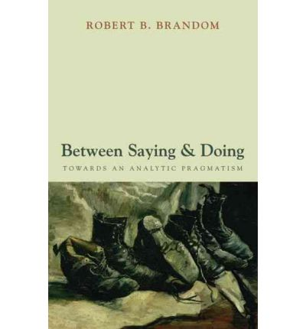
Analytic pragmatism, as I pursue it in Between Saying and Doing, aims to study systematically relations between meaning and use. In particular, it offers an account of a number of pragmatically mediated semantic relations between vocabularies, arguing that these are crucial for understanding both the use of and the meanings expressed by a number of vocabularies that have been of particular interest to philosophers, including logical, modal, normative, semantic, and intentional vocabularies. I regard the idea that one can ignore what is special about the use and meanings of these vocabularies and directly investigate logical, modal, normative, semantic, and intentional facts as a fundamental mistake. It is a mistake of a piece with the one Wittgenstein diagnoses in the Tractatus as resulting from thinking that logical vocabulary has the same expressive picturing relation to facts that nonlogical descriptive vocabulary does.
3:AM: We get a different philosophical landscape from you once we take all this in: you start with Kant and run through to Sellars…! Your approach might be labeled ‘semantic holism’. Have I got this right by saying that (roughly) instead of starting with the pre-sentential units of meaning (words plus logical bits and pieces) and building up meanings, you start with the sentences and inferences to be drawn. Can you sketch how your approach works?
RB: Right. I take it that the basic move in a language game is saying something in the sense of making a claim. That is undertaking a distinctive kind of commitment: an assertional or doxastic commitment. What makes it the claim that it is is the circumstances under which it is appropriate to make the claim, and the consequences of making it. This is a matter of what else would commit or entitle you to make the claim, and what else making it would commit or entitle you to. Understanding a claim, practically grasping its significance, is being able to keep score on how making it changes what the speaker and audience are committed or entitled to. On this picture, claimable (so believable) contents are articulated by inferential relations between their circumstances and consequences of application.
The theoretical idea of conceptual content expressed by subsentential expressions are to be understood in terms of the circumstances and consequences of application they inherit from the contents expressed by the assertional use of declarative sentences involving them—though along another dimension, in an up-and-running discursive practice we typically determine the contents of novel claims from the contents of the concepts applied in expressing them. On this view, assertional commitments and inferential commitments come as an indissoluble package; neither is intelligible in abstraction from the other.
It follows immediately from this way of thinking about things that one cannot have one concept without having many. The idea of grasping just one, isolated concept is incoherent: the sound of one hand clapping. Grasp of a concept, Sellars says, is mastery of the use of a word. More specifically, grasping a concept is a matter of practically mastering its use in making assertions (a version of Kant’s rendering of concepts as “functions of judgment”), which essentially involves placing it in a “space of reasons” (as Sellars called it), inferentially articulated by relations of being-a-reason-for (in either the committing or the entitling sense). So the assertional descriptive use of concepts is part of a package that includes also the inferential explanatory use of those concepts, which is a matter of what can be reasons for their application and what their application can serve as reasons for.
3:AM: Doesn’t this result in denying compositionality ? Isn’t a push-back against your position the issue that it destroys a neat way of explaining why we can use a finite vocabulary to mean a huge number of original things – and also we’d never know if we were making the same sense to anyone else? I guess this is the Fodor challenge – is it one that keeps you up at night sometimes?
RB: Semantic holism at the sentential level is compatible with as much compositionality as there actually is at the subsentential level. Dummett already introduced semantic ‘molecularism’ as an alternative to atomism: attribute sentential meanings based on the use of a small finite set of whole sentences, decompose them by considering the contribution made to those sentential meanings by subsentential expressions occurring in them, and then recompose those subsential meanings to generate sentential meanings for an indefinite number of novel sentences formable from those subsentential components.
In my version, we dissect sentences by grouping them into equivalence classes accordingly as intersubstitution preserves the goodness of inferences. Associating discursive content with singular terms and predicates (to begin with) is practically mastering the special class of substitution inferences they determine. This gives us a place to start in determining the inferential role of novel compounds, because we know things such as that if x walks then x moves, and that if Benjamin Franklin was a printer then the inventor of lightning rods was a printer.
In my view, that’s all compositionality gives us—or needs to. It does not determine all the inferences novel sentences are involved in, by anyone’s lights. As Fodor himself has emphasized in other contexts, one can know a lot about birds and a lot about Antarctica, and not know that Antarctic birds are flightless. It’s just a fact that many things that follow from the conjunction of two properties don’t follow from intersecting what is true of either one by itself: from red + Winesap apple ripeness follows, while from red + blackberry unripeness does (because, as they say, blackberries are red when they’re green). Anybody has to tell a noncompositional story about how we practically master inferences like these.
I think the issue about whether I mean the same as someone else is a different one—though they are often run together. The inferential norms that we bind ourselves by in using public language are shared. When I claim that the coin is copper, I am, whether I know it or not, committing myself to its melting at 1085º C.. I have played that counter in the game, and that is part of what I have committed myself to by doing that. Those same norms bind us all. Of course I might have a different conception of those norms, as evinced by my actual dispositions to claim and infer. But we might equally disagree about what the extensions of our terms are, without that affecting the semantics of our utterances (or, I would say, our thoughts). In any case, things are not in principle more difficult for inferentialists than for representationalists here.
3:AM: So what you call the Kant-Sellars thesis’ is roughly the idea that if you can use ordinary, non-necessary, non-normative language then you’ve got all you need to use necessary, normative language too (is that right?) – what’s the significance of this move?
RB: One of Kant’s big ideas is that besides concepts whose principal job it is to describe and explain empirical goings-on, there are concepts whose distinctive expressive role is to make explicit features of the framework that makes empirical description and explanation possible. The paradigm for Kant is the sort of lawful inferential connection among concepts expressed by counterfactual-supporting subjunctive conditionals (his “hypothetical judgments”). For Sellars these categorial concepts include not only alethic modal vocabulary, but also deontic modal normative vocabulary. Such concepts are, as I want to say, explicative of structural semantic and pragmatic features of discursive practice as such. Discursive practice is essentially, and not just accidentally, an implicitly normative practice, in which practitioners undertake and attribute commitments and responsibilities and claim and exercise authority, their entitlement to which is always potentially at issue. And what makes such a normative practice discursive, we inferentialists claim, is that it is essentially, and not just accidentally, a practice of giving and asking for reasons—that is, a practice of asserting and inferring. Propositional contents are claimables and believables: what can be offered as reasons and reasons demanded for.
The inferences that they can serve as premises and conclusions of are counterfactually robust inferences, which are made explicit by the use of alethic modal vocabulary, paradigmatically subjunctive conditionals. Besides being in this sense explicative of structural features of any autonomous discursive practice (any language game one could play though one could play no other), deontic and alethic modal vocabulary can be elaborated from the use of ordinary empirical descriptive vocabulary, in the sense that anyone who can use such vocabulary already knows how to do everything they need to know how to do in order to master the use of such vocabulary. That is what, in my version of Sellars’s version, becomes of Kant’s claim that such categories or pure concepts of the understanding are graspable a priori. In Between Saying and Doing I offer a detailed account of this expressive role, which is distinctive not only of alethic and deontic modal vocabulary, but also, I claim, of logical vocabulary, ontological vocabulary (such as ‘object’, ‘property’, ‘fact’, and ‘proposition’), and semantic and intentional vocabulary.
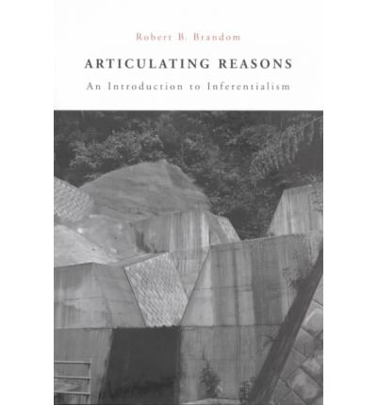
3:AM: Do you see your approach as being crucial for the development of the artificial intelligence programme? Is your view that the traditional analytic philosophical approach of Russell and Quine lacked the resources that your extended analytic/pragmatist approach brought?
RB: I do think that those pursuing AI projects should be thinking both about inferentialist approaches to semantics, and about deontic scorekeeping approaches to pragmatics. (Indeed, the latter idea—that what one must do in order thereby to understand what someone is saying is keep track of how their utterances change what they and other people are committed and entitled to—is in fact the basis for the AI in one of the versions of “The Sims”.) In addition, my particular form of analytic pragmatism—thinking systematically about the relations between meaning and use, and in particular about pragmatically mediated semantic relations between vocabularies—brings into view a different way of thinking about the task of AI. The classical project of AI, what my friend John Haugeland called GOFAI—Good Old-Fashioned Artificial Intelligence—was subject to criticisms, by him, developing thoughts of his teacher Bert Dreyfus, on the basis that it implausibly required making explicit, in the form of rules (programs), everything that was implicit in our skillful, embodied social practices. What I call the “pragmatic elaboration” AI project, by constrast, is to specify a set of practices meeting two conditions.
First, each practice in the set can be engaged in by systems that do not engage in any discursive practices, and second, it is possible to algorithmically elaborate that set of practices into (the capacity to engage in) some autonomous discursive practices. Algorithmic elaboration is putting together primitive abilities using only a small set of primitive elaborative abilities (such as moving to the next instruction on a list and moving to a different instruction conditionally upon the results of some yes/no test) in the way the capacity to do long division can be algorithmically elaborated from the abilities to multiply and to subtract. In Between Saying and Doing I argue that there are reasons for skepticism about the feasibility of the pragmatic elaboration version of AI. But they are quite different from the reasons for skepticism about the prospects for GOFAI.
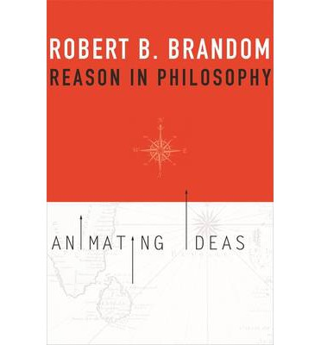
3:AM: Looming over this is also your strange engagement with German Idealism. Here we can see why you step away from the strong empiricist tendencies of an Ayer or Carnap and move back to a tradition where reason distinguishes us as rational animals. Kant and Hegel are the killer apps here, along with Descartes, Spinoza and Leibniz. Is the appeal the fact that these thinkers pushed the idea that rationality is a normative idea, that we live in a ‘space of reasons’?
RB: I’m not sure I’m willing to give you that engagement with German Idealism today is “strange”. Perhaps we could agree on “unusual”. And as far as Kant goes, not even that unusual anymore, I think. A golden age in the Anglophone appreciation of Kant was already incipient by 1970, opened up by Rawls on the practical side, and Strawson and Bennett on the theoretical side. We are now a couple of academic generations into the renaissance they initiated. And Hegel is just too interesting a reader of Kant to be left out once one decides to take Kant seriously.
One of Kant’s master ideas is that what distinguishes genuine knowers and intentional agents from merely natural creatures is that judgments and actions are things their subjects are in a distinctive way responsible for. They express commitments. They are exercises of a special kind of authority. Responsibility, commitment, authority are all normative concepts. What distinguishes genuinely discursive beings from those that exhibit only the practical intentionality on display at a high level in the goal-seeking behavior characteristic of mammalian predators, is not the presence of some distinctive Cartesian mental substance. It is being subject to a special kind of normative appraisal. The difference for Kant is not ontological, but deontological. What one is principally responsible for in judging and acting is having reasons for them. Those reasons are what entitles one to those commitments. Judgments and actions are rational commitments in the sense that they are liable to assessment as to one’s entitlement to those commitments in terms of the reasons one has to judge or act that way. As discursive beings, we live, and move, and have our being in a normative space of reasons.
As I see things, this is what lies behind another of Kant’s innovations: taking the judgment to be the minimal unit of experience and sapient awareness. For judgments are the minimal units of responsibility. Concepts are “functions of judgment” in that it is what concepts we apply in judging (or endorsing a practical maxim) that determine what we thereby make ourselves responsible for. That is their rulishness. This overarching commitment to the essentially normative character of discursive intentionality is also the basis on which we should understand what Kant calls the “subjective” and “objective” aspects of the form of judgments. The “I think” which can accompany all judgments is the formal mark of who is responsible for the judgment. The “object = X” which marks the implicit claim to objective validity of judgments is the formal mark of what one thereby makes oneself responsible to, the standard for assessments of the correctness of the judgment.
It follows that for Kant the biggest philosophical task is understanding the normativity that is the essence not only of our practical engagements with the world, but also of our cognitive ones. The most urgent philosophical task is to understand the normative bindingness (Kant’s “Gültigkeit”) of concepts, and what it is for us to bind ourselves by rules in making judgments and acting intentionally. These are all ideas that I think are of the utmost importance today, and why we cannot afford to ignore the legacy of German Idealism.
3:AM: You take Hegel’s notion of Anerkennung as a key to getting straight the relationship between rational agents don’t you? This seems to involve ideas of recognition, community and responsibility at its core. Can you say something about why this space of reasons’ is a social space, and whether this is another reason for being attracted to this approach to rationality – it opposes an individualistic, atomized approach that might be supposed in classical representational semantic theories?
RB: The idea that discursive intentionality should be understood as an essentially normative phenomenon was recovered for our own time by the later Wittgenstein. Only one strand of this thought is the normativity of conceptual content that Kripke emphasized and that has been crystallized in the literature on the “rule-following considerations.” Wittgenstein’s stories often aim to underline this normative dimension to thought in general. So for instance he asks us to imagine someone who is asked by a mother to “teach the children a game.” Upon her return an hour later she discovers that the children have been taught to gamble for money with dice. Horrified, she responds: “I didn’t mean that kind of game.” Wittgenstein thinks that what she says is true, even in the case where she didn’t at all consider this possibility. But, his interlocutor asks, how can this be so? What is it about the desire expressed in her request that settled it that shooting craps did not fall under the scope of her request? How did that intentional state or its linguistic expression, reach out to all the possible ways of responding to settle that this response was not appropriate, did not count as correctly responding?
Wittgenstein clearly thought that understanding such phenomena requires taking seriously the situation of intentional states and their linguistic expressions in social practices that are themselves governed by implicit norms. I understand Hegel as already having made a move of this same general kind. He naturalized Kantian normativity, bringing it down from the heaven of noumenal activity presupposed by our empirical activity into the realm of social practice. On this line, for Hegel “all transcendental constitution is social institution,” as John Haugeland characterized this reading. “Geist” is Hegel’s term for the whole realm of implicitly normative social practices, all the doings subject to assessment according to those norms, and all the institutions they make possible.
At its core, for him as for Wittgenstein, is language. “Language (Sprache) is the Dasein of Geist,” he says in the Phenomenology—which is a phenomenology of spirit (Geist) just as taking that socially instituted normativity in all of its manifestations as its topic. Hegel’s social practice approach to the normativity that is not only characteristic, but constitutive of discursive intentionality, differs from Wittgenstein’s way of working out that idea in two fundamental ways, both of which make it especially attractive to me. First, Hegel, unlike Wittgenstein, is a rationalist. He follows Kant in seeing the norms articulating what is a reason for what as at the core of the normativity of discursive intentionality. Transposed into his social key, this means that while Wittgenstein insisted that our language games have no “downtown”, Hegel thinks—as I would put it—that practices of giving and asking for reasons are the “downtown” of our discursive social practices. Second, Hegel is a systematic philosophical theorizer in a way Wittgenstein explicitly and emphatically is not. (Thinking, to my mind mistakenly, that eschewing such theorizing follows from the claim—the only one that appears verbatim in both the Tractatus and the Investigations—that “philosophy is not one of the natural sciences.”) Hegel offers a sophisticated account of the metaphysical structure of social normativity.
The central role in that story is played by the concept of recognition. In a slogan, he takes it that social substance, Geist, is synthesized by reciprocal recognition. This is what he makes of the Enlightenment idea that norms governing human conduct are neither features of the natural world (as what was “fitting” was for the Greeks) nor the result of divine commands, but part of the human social world. There were no normative statuses (no proprieties, no commitments or responsibilities, no authority) apart from normative attitudes; it is people practically holding each other responsible, attributing authority, that institutes such statuses. (This is the core thought he extracts from social contract theories of political obligation.) Adopting normative attitudes towards some others, taking them to be the subject of normative statuses, to be able to commit themselves, to exercise authority, to undertake responsibilities, he calls “recognizing” them. I actually have the authority to commit myself, to make myself responsible (the normative status at the center of Kant’s understanding of discursive beings) just in case I am taken to have that authority by those I grant the authority to hold me responsible. Only such reciprocal recognitive attitudes institute genuine normative statuses.
This is an extremely rich idea about the basic metaphysics of normativity. It takes a lot of working-out. But one can get some taste of its flavor by thinking about the difference between the properties you have, on the one hand, when you aspire to be a good philosopher and think that you are one, and, on the other hand when you are taken to be (recognized as) a good philosopher, not just by anybody, but by those you take to be good philosophers—the ones you take to be (recognize as) authoritative about such things. The first is a subjective attitude. The second has solidified into a genuine normative status by becoming a social status—one instituted by reciprocal recognition.
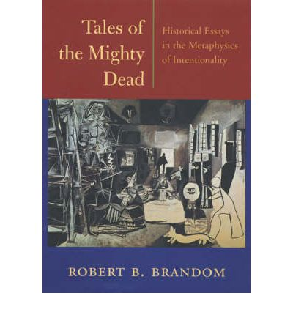
3:AM: Inferences are central to your account. Can you explain what you take to be the role of inferences? Why are they so important to your account of reasoning? (After all, its not always clear what a reason has to do with any inference.)
RB: You make a very important point. Semantic rationalists in general think of discursive content in terms of role in reasoning. And there is indeed a very great deal more to reasoning than inferring: drawing a conclusion from some premises. Making distinctions, formulating definitions, and producing constructions of some objects, concepts and claims from others are just some of the other activities that are not only rational but in an important sense reason-constituting. The specifically inferentialist version of semantic rationalism amounts to a bold methodological commitment to understanding all these other sorts of activities and the relations that articulate them in terms inference and inferential relations, which are in that sense taken to be fundamental.
I take it that assertions, and the doxastic commitments they express, are what distinguishes specifically discursive practices from the rest. Further, I think assertions and doxastic commitments are essentially, and not just accidentally, fodder for inferences. They can both serve as reasons and have reasons demanded for them. Giving and asking for reasons is by no means all we do with language, but it is (contra Wittgenstein), the “downtown” of the rest of the suburban sprawl, whose presence demarcates anything as a Sprachspiel, a language game in the verbal, rather than the merely vocal, sense. That is why the inferential relation of being-a-reason-for, holding in the first instance between claimables (=believables), is semantically fundamental.
3:AM: Is your Hegelianism true to the historical figure or is that less interesting to you than how his ideas have been open to developing your version of analytic pragmaticism? I guess another way of asking this is to ask: was Hegel really a proto-analytic-pragmatist? Wouldn’t Russell have raged at the thought? And if you’re a Hegelian, does that make you an Idealist?
My principal interest is in what I can learn from Hegel (indeed, from any thinker) about philosophical issues I am interested in, such as the nature of conceptual contentfulness and how social practical attitudes can institute discursive normative practices. To learn what he has to teach, one needs to get him right: to understand properly the content of his claims. For an inferentialist, that is a matter of understanding what those claims commit him to and what would commit him to them, what they entitle him to and what would entitle him to them, what is incompatible with them, and so on. The holism that comes with such semantic inferentialism teaches that the inferences involved are massively multipremise material inferences.
So what conclusions one can draw from any particular set of claims depends on what other claims are available as auxiliary hypotheses for drawing those inferences. Selecting those collateral premises from other claims one attributes to the author or text one is trying to understand yields a perspective on the content I call a “de dicto” reading. Selecting them from claims one endorses (takes to be true) oneself yields a perspective on the content I call a “de re” reading. The key point is that for the inferentialist, these are equally valid perspectives on the content of the claims actually made (which are something like functions from sets of auxiliary hypotheses to consequences, incompatibilities, and so on). I take it that one engages philosophically with a thinker by offering de re readings. But one can only do that if fully grounded in de dicto ones.
My Hegel is a pragmatist because he thinks you can’t understand conceptual contents apart from an understanding of conceptual norms, and he understands those norms as instituted by social recognitive practices. My Hegel’s idealism consists principally in a reciprocal sense-dependence thesis (which does not entail a corresponding reciprocal reference-dependence thesis) concerning the categories that structure the objective world and those that structure our subjective practices: you can’t understand concepts like object, property, fact, and law except as part of a package that includes understanding concepts like referring, describing, asserting, and inferring—and vice versa. (Claiming this does not commit one to the crazy claim that if no-one had ever referred, described, asserted, or inferred, then there would have been no objects, properties, facts, or laws. That would be a reference-dependence thesis.) In that sense of “idealism” I am an idealist.
3:AM: As is Hegel, so too is Sellars a key influence on your work. You say he’s greater than Quine and as important as Peirce. A naturalistic Kantian, fighting from a Kantian perspective to square the manifest image of our life-view with the scientific world view, what are the Kantian ideas of his that have been most influential in your own thinking
RB: Sellars is the lens that brought Kant into focus for me. He starts with Kant’s insight that discursive intentionality essentially involves liability to assessment according to norms, and that the norms in question are those concerning justification by reasons. In a famous passage from Sellars’s masterwork Empiricism and the Philosophy of Mind he says: “[In] characterizing an episode or a state as that of knowing, we are not giving an empirical description of that episode or state; we are placing it in the logical space of reasons, of justifying and being able to justify what one says” (EPM §36)
His account of the contents of ordinary empirical descriptive concepts gives Kant’s normative rationalism a specifically inferentialist twist: “It is only because the expressions in terms of which we describe objects…locate these objects in a space of implications, that they describe at all, rather than merely label.” [CDCM §108] And Sellars takes over from Kant the idea of concepts whose principal expressive job is not empirical description or explanation, but making explicit essential features of the framework of discursive practices that makes describing and explaining possible. For Sellars these concepts include alethic modal vocabulary, deontic normative vocabulary, and ontological-categorial vocabulary such as ‘property’ and ‘fact’. Following Carnap, he understands such concepts as playing broadly metalinguistic expressive roles. For instance, he understands the job of modal concepts to be expressing the lawful relations among properties and states of affairs that support the counterfactual-supporting inferences in virtue of which descriptive concepts are contentful—which is why, he claims, “description and explanation go hand in hand.”
I think these are all great ideas. It seems to me that one promising way forward for us today is to develop and exploit them further, starting from what Sellars made of these core Kantian thoughts. I explain how I propose to do that in my most recent book From Empiricism to Expressivism: Brandom Reads Sellars.
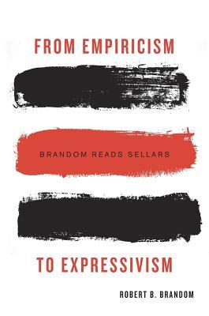
3:AM: You count his project as a form of expressivism. Can you say what you mean by that and if he is right does it commit us to thinking that we’re not describing anything when we use terms like ‘red’ or ‘circular’?
RB: Many of the most potentially philosophically puzzling sorts of locutions—modal and normative vocabulary, intentional and semantic vocabulary, logical vocabulary, and ontologically categorizing vocabulary such as ‘property’, ‘object’, ‘proposition’ and ‘fact’—play a distinctive expressive role that is not played by ordinary empirical descriptive vocabulary. They make explicit in the object language features of what one must do in order to use ordinary empirical descriptive vocabulary. They are, Sellars claims “covertly metalinguistic,” but as I think the point should be understood, the metalanguages in question are not semantic metalanguages, but pragmatic ones. In the first instance, they let us talk about the use of expressions, rather than their meanings—what we are doing rather than what we are saying. This species of expressivism is rationalist and inferentialist, rather than emotivist: what is expressed is features of inferential practice and attitudes of doxastic commitment or endorsement.
By contrast to Sellars (and most expressivists), I hold that playing this sort of expressive role is not incompatible with also playing a broadly descriptive, fact-stating role. The claims made and (when all goes well) facts stated by using vocabulary that plays this sort of pragmatic metalinguistic role are distinctive in that they cannot be understood apart from an understanding of what one is doing in making claims and inferences—though they would in general still be facts even if no-one ever asserted or inferred (the dependence is in the realm of sense, not reference).
3:AM: One push back against the Sellarsian project – and I guess your too – is that he was committed to the ‘linguistic turn’ in philosophy at the beginning of the twentieth century – and that the idea that philosophy is properly committed to analysis of language is now over. Philosophers are now wanting to philosophise things like time again, and not just the concept of ‘time.’ Etc. Isn’t there something to this criticism – science is saying the world is a certain way and for philosophers to just discuss how we might talk about the world and not think about the world is to avoid the key issue. There is no way of fully squaring the manifest image with what we know about the world, even if you call it ‘the myth of the given’.
RB: I do think that understanding language is part of the core of the philosophic enterprise—but not because I think philosophy consists in the analysis of the concepts expressed by using various linguistic expressions. Rather, I think one of the core concerns of philosophy is to understand us as creatures who understand. And I think what makes us sapient, and not merely sentient, is that we can talk. So we have a central philosophical interest in understanding what it is to engage in discursive practices, and how and why doing that is so transformative. The move from the practical intentionality of the beasts to our discursive sort of intentionality, which is the move from sentience to sapience, is what makes room for Hegelian Geist in the realm of Natur. Language (Sprache) is the Dasein of Geist, Hegel tells us.
I think, with Hegel and Sellars, that the discursive realm of Geist is an essentially normative space, that normative statuses are instituted by social practical recognitive attitudes and practices, and that distinctively discursive (in Kant’s sense of conceptually articulated) norms are instituted by assertional and (so) inferential practices of giving and asking for reasons. Other approaches to understanding this fundamental issue are of course possible. But nothing about this broadly Hegelian way of understanding what is distinctive of us commits one to restricting philosophy to a narrow project of conceptual analysis.
3:AM: You’re sometimes called one of the Pittsburgh Hegelians. The other is your colleague John McDowell. You don’t agree on everything about Hegel though do you – so where is McDowell’s Hegelianism most unlike your own?
RB: Not surprisingly, our different readings of Hegel (and for that matter, Kant and Wittgenstein) mirror our larger metaphilosophical differences. My Hegel is a Kantian, pursuing the Enlightenment project of offering a constructive, systematic metaphysics of discursive intentionality. As I said above, one of his big moves is bringing Kant’s insight into the essentially normative character of discursive intentionality down to earth, according to something like the slogan “All transcendental constitution is social institution.” John sees Hegel rather as critically continuing and radicalizing Kant’s project of getting us beyond metaphysics, constructively in the direction of an Aristotelian naturalism.
3:AM: These are strange days for philosophy. Some say its in the doldrums, others that it is trivial and should leave the room for the physicists. Why do you say there’s still space for the philosophers? Why should we listen to what they’re saying?
RB: I think it is a very exciting time to be working in philosophy. We’ve inherited an incredibly rich set of ideas. I’ve been talking about a subset of them that come from Kant and Hegel, from Wittgenstein and the American pragmatists, from Sellars, and from the analytic tradition in the philosophy of language. Those are just the ones that I’ve spent the most time developing, overlapping those that matter to other contemporary philosophers whose work I find inspiring, such as Huw Price and Sebastian Rödl. Some of the most original and transformative philosophy today is being done in the neo-Aristotelian tradition represented by my colleague Michael Thompson and Irad Kimhi. John McDowell swims powerfully and easily in both these currents of thought. It seems to me that anyone with philosophical bones who reads what I’m reading—both among the mighty dead and among the rising generation—should find their pulse quickening.
For me, the question of whether or not the philosophical tradition is in the doldrums (or a Slough of Despond) should be understood in terms of the power and originality of the ideas available to be worked with, rather than in terms of the ultimate interest of whatever areas are “hot” in the profession in a purely sociological sense. I don’t know much about that, and don’t care much about it, either. (I’m told that when a survey asked undergraduates whether they thought it was true that today’s college students are more ignorant and apathetic than those of earlier generations, the commonest answer was: “I don’t know, and I don’t care.” I certainly don’t want to endorse that attitude in general, but on the issue of the current state of the discipline, considered sociologically, I’m ‘fessing up.)
I think what distinguishes philosophers as such is that we study humans as discursive beings—that is, as normative rational creatures, in the sense that what we in the fullest sense do (including believing) is subject to normative assessment as to the goodness of the reasons we have for doing or believing that. (How rational we are in the sense of how successful we are at actually fulfilling our obligations to have such reasons is quite a different matter.) Norms and inferential-justificatory behavior can be studied empirically. But the question of what norms and good inferences are, and of how to understand the kind of creatures we are in virtue of living in such a normative space of reasons seem to me to be of the first importance—not only for philosophers, but for the culture at large. There is a lot we don’t understand about these things. But we are not without clues. The trove of ideas in the vicinity that we have inherited and have not yet begun to squeeze dry make this an altogether invigorating time to be doing philosophy.
3:AM: And for the readers here at 3:AM, are there five books that you could recommend to us that would help us delve further into your philosophical world?
RB: Of my own books, Making It Explicit and Between Saying and Doing are the most important, but any of the more recent ones offer a general overview. The contemporary philosopher whose development of pragmatism I find most consistently interesting and stimulating is Huw Price, whose Naturalism Without Mirrors serves as a good introduction. The two recent books I have found to be most original and transformative are Mark Wilson’s Wandering Significance, which takes our understanding of how empirical concepts actually work to a new level, and Danielle Macbeth’s Realizing Reason, for its sweeping historical reconceptualization of discursive understanding, seen through the lens of its most perfect realization in the concepts of mathematics.
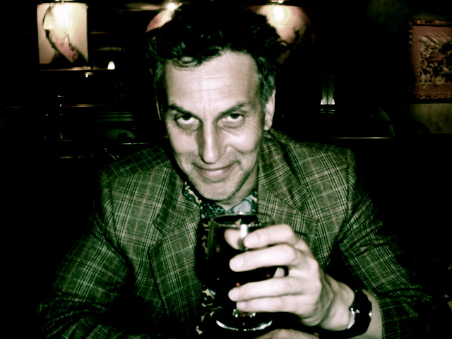
ABOUT THE INTERVIEWER
Richard Marshall is still biding his time.
Buy his book here to keep him biding!
First published in 3:AM Magazine: Friday, June 19th, 2015.
•

most recent

- Interviews » The End Times » Between Saying and Doing
- Fiction » Are you a Doctor, Sir?
- Fiction » The Cloning Passion, A Sort of Footnote
- Essays » On Blood Writing
- Reviews » The Scandal of Reality: A Response to On Wing by Róbert Gál
- Interviews » The End Times » On German Materialism
- Essays » The Rise and Fall of Fantasy
- Essays » Three Visions of Zosimus
- Interviews » The End Times » Thinking About Mindreading, Mirroring and Embedded Cognition et al…
- Fiction » Doctor on the Hill

• buzzwords
- The Sex-Appeal of the Inorganic
- The Missing Links
- An Evening with University of Greenwich writer in residence Paul Ewen, and special guests
- Whatever it is, we’re against it.
- The Life and Work of Jonathan Coe
- Words without Borders seeks book reviewers
- The Missing Links
- Film Without Film
- Tom McCarthy: ‘Think Tank’
- The Dilly: A Secret History of Piccadilly Rent Boys

All content © 2000-2015 / Designed and built by Rhys Tranter and Florian Kräutli. Based on an earlier structure built by STML.
Email webmaster@3ammagazine.com with any problems.
Login

